STATE OF New mexico

DEPARTMENT OF transportation

e-grants

SUBGRANTEE USER MANUAL
20160421 Final

For general questions or assistance gaining access to e-Grants, contact: | Kimberly Wildharber  (505) 490-1121 – Kimberly.Wildharber@state.nm.us

Table of Contents
Table of Contents 2
e-Grants System Requirements 3
Operating System 3
Internet Connection 3
Web Browser 4
Adobe Acrobat Reader 4
System Access 4
Applying For System Access 4
Requesting a Password Change 5
Subgrantee User Roles 6
Project Director 6
Financial/coordinator 7
Viewer 7
Subgrantee User Role Chart 7
Summary Of Naviagation 7
Initiation 7
Application 7
Claim and activity reports 8
Inventory Records 8
Filling out the document 8
Application 8
Proposal 8
Operational Plan 8
Grant Agreement 8
Amendment 8
Submission Of Document 8
My Home 9
User & Organization Management 11
My Profile 11
My Organization(s) 11
Organization Members 12
Additional addresses 13
My Opportunities 14
My Inbox 14
My Tasks 15
My Applications / Executed Contracts & My Reporting Documents 15
Document Menu 16
View, Edit, Complete Forms 17
Navigation Links 17
You Are Here 18
Multi-Narrative Forms 18
Repeatable Rows 18
Change The Status 19
Access Management Tools 19
Add/Edit People 20
Examine Related Items 21

e-Grants System Requirements
The State of New Mexico Department of Transportation’s Electronic Grants System (e-Grants) is designed for use by the vast majority of computer users with little or no changes to the computer environment. The requirements that are mentioned below are common computer elements that should be present on most machines.

Operating System
e-Grants is designed for two of the most common computer operating systems: Windows and Macintosh. It has not been tested and is not supported on other common operating systems such as UNIX, Linux, Android, or iOS. Users with a Windows operating system are required to have an operating system that is Windows XP SP2 or higher. Users with a Macintosh operating system are required to have an operating system that is MacOS 7.5 or higher.

Internet Connection
e-Grants is a web application designed to be accessed via the Internet. Internet connections can be established by connecting your computer or network to a modem purposed with providing a gateway into the internet. For the purpose of accessing e-Grants, a minimum connection speed of 33.6 kbps (kilobits per second) is required. Faster connection speeds will help to improve the speed at which e-Grants operates.
Most office locations and computers will already be connected to the internet. If you find yourself without internet access or are unsure, please contact your organization’s network administrator or Kimberly Wildharber.

Web Browser
e-Grants is designed to be compatible with common web browsers including Safari, Opera, Mozilla Firefox, and Internet Explorer. It has not been tested and is not supported on Google Chrome. If using Internet Explorer and your version is higher than IE8, please ensure to enable compatibility mode while accessing e-Grants.

Adobe Acrobat Reader
Adobe Acrobat Reader is used to view PDF (Portable Document Format) documents. e-Grants automatically generates grant documents in PDF format using information that is saved into various narrative and budget pages. Using Adobe Acrobat Reader you may choose to view, print, or save these documents. If you do not have Adobe Acrobat Reader you can go to www.Adobe.com and download it for free.

System Access
To access the e-Grants site, open a web browser and navigate to the following URL:
***URL TO PRODUCTION***
Most users will be supplied with a username and password via email prior to navigating to e-Grants. Simply enter in the given username and password to gain access to the system.

Applying For System Access
If you do not already have a username and password, you may apply for access to e-Grants.  From the login page, click on the New User? hyperlink, as displayed in Figure 1. This will redirect you to the registration page, titled My Profile.  On this page, complete all of the fields that are marked with a red asterisk (*), as displayed in Figure 2, then click the SAVE button. Once successfully saved without errors, you will receive a confirmation message, as displayed in Figure 3. | 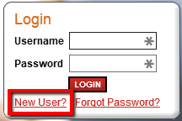  Figure 1: Displays the Login control on the first page of the e-Grants site.
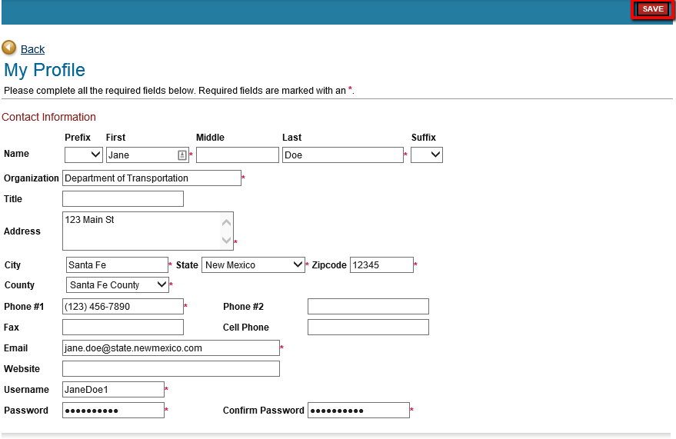
Figure 2: Displays the proper completion of the registration page. 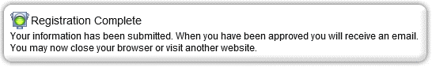
Figure 3: Displays the expected confirmation message after successfully saving the registration page.

Requesting a Password Change
In the event that you forget your password and are unable to access the system, you may request a new password by clicking the Forgot Password? hyperlink. This will redirect you to the password change page, titled Forgot Your Password? Enter in your username and email address, then click the RESET MY PASSWORD AND EMAIL ME THE NEW ONE button, as displayed in Figure 4. This will email you a new password that could be used to log into the system. You may then change your password via My Profile. See the USER & ORGANIZATION MANAGEMENT section of this document for more information.
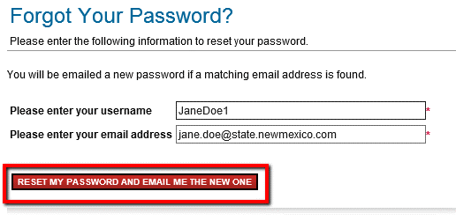
Figure 4: Displays the Forgot Your Password page.

Subgrantee User Roles
Users within e-Grants are granted access as a user role. The user’s role within the system will help to determine the accessibility to functionality, documentation, and responsibilities. The three user roles that are accessible to you as a subgrantee are listed below, along with a description of the user role’s accessible functionality, documentation, and responsibilities.

Project Director
The Project Director role is one that is designated for the main user of e-Grants that will represent your organization. Typically, this user is the one whom manages requests for grant funding for your organization. The Project Director role will have the ability to fully manage all data that is associated with their organization. They will also have the ability to initiate, complete, and submit all documentation that is associated with their organization. The Project Director is usually the main point of contact for an organization and is typically the role designated with the task of completing documentation.

Financial/coordinator
The Financial role is one that is designated for the financial staff of an organization that may not fit into any other roles. This role is more of a supportive one, in that a user with this roll will not have the ability to manage organization data, will not be able to initiate a document, nor will they have the ability to submit a document. They will, however, have permissions to fully complete a document. A perfect example would be an individual that is tasked with completing a Claim and Activity Report but would then pass it along to the Project Director role for review and submittal.

Viewer
The Viewer role is one that is designated for organizational staff that need to ability to view the information entered into e-Grants, but will not need the ability to modify any of the data. The Viewer role will only have the ability to view organizational data and documents.

Subgrantee User Role Chart

Summary Of Navigation

Initiation

Application
This is your initial document and will need to be initiated by the Project Director.
Navigate to the My Opportunities tab and, click the APPLY NOW button. (As displayed in Figure 10)

Claim and activity reports
Claims are automatically initiated on the first of every month once the Operational Plan is in Grant Agreement Executed. However, if there is a need to initiate a supplemental claim the Program Manager can initiate the claim from Examine Related Items.

Inventory Records
Inventory Records are used to track all equipment requests over $1,000. An Inventory Record needs to be initiated by the Project Director while the Claim is still in process. Navigate to the Document Menu, go to Examine Related Items and select “Initiate a/an Inventory Record. (As displayed in Figure 25)

Filling out the document
Once you’ve initiated the document you will be taken to the Document Menu, from here you will navigate to View, Edit, and Complete Forms. This will display the list of forms needing to be completed. You can navigate the forms through the Navigation Links or the forms list using You Are Here. You will need to navigate to each form and ensure they are all saved with no errors. (As displayed in Figure 17)

Application

Proposal
When you first initiate the application you will only see the pages which make up the proposal which upon completion, will be submitted and reviewed by the Program Managers. The Program Managers will then determine which programs you are eligible for based on the information provided.

Operational Plan
Once the Proposal is reviewed and the eligible programs are identified, the proposal becomes an Operational Plan. At this status step you will see which programs you are eligible for based on the Negotiation Worksheets listed on the Forms Menu. Each Negotiation Worksheet can be filled out by the LEL before being reviewed and submitted by the Project Director.

Grant Agreement
After the Operational Plan is submitted it goes into review and reaches Grant Agreement. In this stage the contract is generated and signed by both parties.

Amendment
While the application is in the Grant Agreement Executed process step you have the option to request an amendment in order to change, increase, extend information, or amend the signature authority in the Grant Agreement. You can do so by Changing the Status to Amendment Request in Process. Then navigate back to the Document Menu using You Are Here, select to View, Edit, and Complete Forms and you will see a new form on which you can provide information on the reason for the amendment.

Claim and Activity Report
Every month a Claim and Activity Report will need to be filled out even if there were no activities for that month. The documents are automatically initiated on the first of the month and will be available in the My Tasks section of your home page.

Submission Of Document
Once all forms are complete you will need to navigate back to the Application Menu using You Are Here and click Change the Status. From here, a list of possible statuses will appear. To change the status of the document, click on the APPLY STATUS button located directly beneath the desired status, as displayed in Figure 22.

My Home
The My Home page is the main menu of e-Grants. From here, you are able to navigate to the rest of site available to your user role. From anywhere in the system, you are able to return to this page by clicking the My Home hyperlink located in the top left of the first navigation bar.
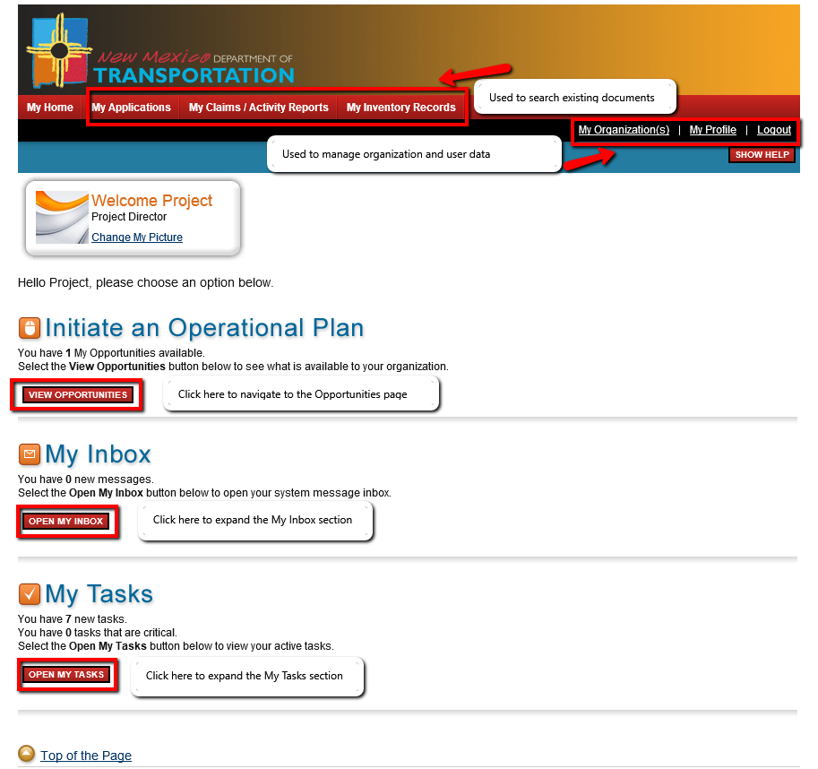
Figure 5: Displays the My Home page. This page is available upon gaining access to e-Grants. From here, you may navigate to the rest of the activities in e-Grants.

User & Organization Management
In e-Grants, it is imperative that the information found within your user profile, and all organizational information remains up to date. Many of the key data points found within documents are derived from this information. Not entering any information or entering in the incorrect information could lead to Operational Plans, Claim and Activity Reports, and Inventory Records to be submitted incorrectly.

My Profile
The My Profile page can be utilized to keep your user information up to date. You may update your user record information at any time by clicking on the My Profile hyperlink located in the second navigation bar. Once you click the My Profile hyperlink, you will be redirected to the My Profile page, as displayed in Figure 2. Once here, you are able to modify your contact information and change your password. To modify your contact information, enter data into the fields that are available on the page, with exception to the two password fields, then click the SAVE button. To change your password, enter a new password into both of the password fields, and click the SAVE button.

My Organization(s)
The My Organizations(s) page can be utilized to keep your organizations’ information up to date. To navigate to the Organization page, click on the My Organization(s) hyperlink located in the second navigation bar.
If you are a member of two or more organizations, you will be redirected to the My Organization(s) page with a table of available organizations. Click on the name of the organization that you would like to modify. This will redirect you to the Organization Information page for that organization. If you are a member of only one organization, you will be redirected to the Organization Information page for that organization.
You can modify your organization’s contact information by entering data into the fields, then click the SAVE button.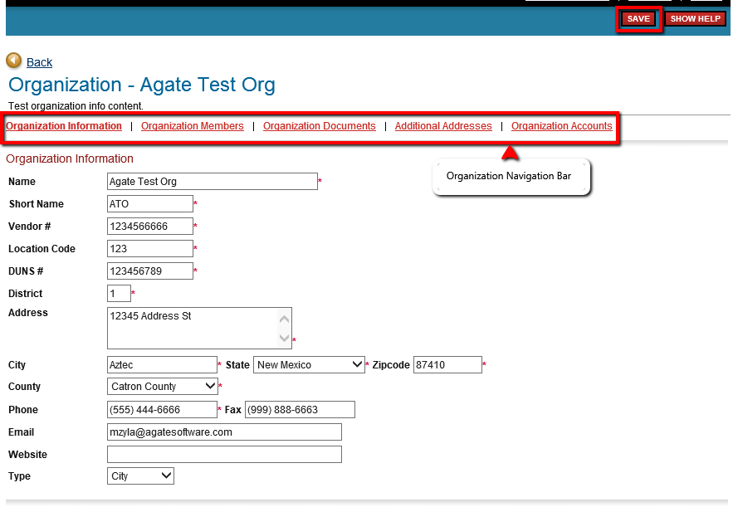
Figure 6: Organization Information page. Can be utilized to keep organization data up to date.

Organization Members
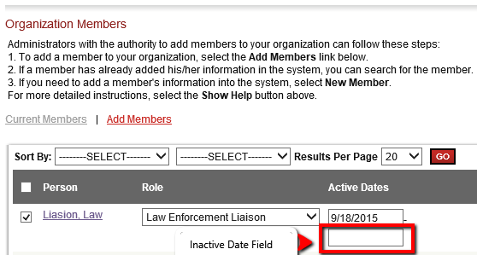
By utilizing the Organization Members page, you are able to manage the users associated with your organization. Click on the Organization Members hyperlink to navigate to the Current Members page, as displayed in Figure 7.
To navigate and view/modify a member’s contact information, click on the target member’s name. This will redirect you to the Organization Members page of the target member.
To modify the organization role of a member, select the desired role in the drop down list and click the SAVE button.
It is ill advised to remove a member from the organization since all historical data of the target member being associated with the organization will be lost.
Figure 7: Displays the Current Members page, highlighting the Inactive Date Field.
Rather, you could inactive the user. This will instruct the system to discontinue adding the user to any organization documents in the future. Keep in mind that the inactivated user will still be able to view past documents. To inactivate an organization member, enter in an inactive date and click the SAVE button.
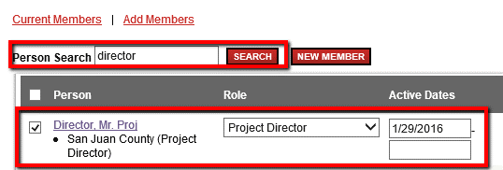
To add a new member to the organization, click on the Add Members hyperlink. This will redirect you to the Add Members page.
To add an existing user to your organization, enter the user’s name in the search bar and click the SEARCH button. This will display a list of users that match the search criteria. Once you find your target user, place a check in the box to the left of their name, select their role within the organization, and then click the SAVE button. (As displayed in Figure 8)
Figure 8: Displays the Person Search section of the Add Members page.

To add a user that does not currently have access to the system, click the NEW MEMBER button. This will redirect you to the Add/Edit Members page. Enter data into all of the fields that are marked with a red asterisk (*), then click the SAVE & ADD TO ORGANIZATION button. This will add the new user to the organization’s members, and will also send the new user an email notification that will communicate that they have been granted access to e-Grants, along with direction on how to navigate to the site using a web browser. Lastly, their newly created username and password will be displayed in the email.

Additional addresses
Along with ensuring the contact information and organization users are up to date, it is imperative to ensure that the fiscal address is current as well.
To navigate to the Additional Addresses page, click on the Additional Addresses hyperlink located in the Organization Navigation Bar. This will redirect you to the Organization Additional Addresses Menu as displayed in Figure 9.
Complete all of the fields that are marked with a red asterisk and click the SAVE button.
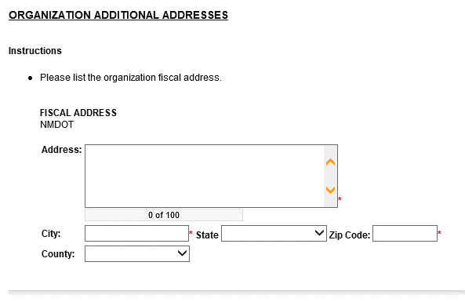
Figure 9: Displays the Organization Additional Addresses page.

My Opportunities
The My Opportunities page will allow you to initiate an Operational Plan. To navigate to the My Opportunities page, click on the VIEW OPPORTUNITIES button available on the My Home page. (As displayed in Figure 5)
Each opportunity listed will display the name of the opportunity, the organization the opportunity is available for, and the organization that is offering said opportunity. More so, it will also display the date range of which an application is available, the date range of the life time of the funding opportunity, and the due date of the application. Lastly, a description of the opportunity will also be provided.
To initiate an application for an opportunity, click the APPLY NOW button. (As displayed in Figure 10)
Figure 10: Displays an available opportunity that is listed on the My Opportunities page.

My Inbox
The My Inbox section of the My Home page will display all system notifications that have been sent to you. Typically, these notifications will be messages sent based on another user’s actions in e-Grants. To expand the My Inbox section, click on the OPEN MY INBOX button. To read the full message, click on the Subject line of the target message, as displayed in Figure 11.
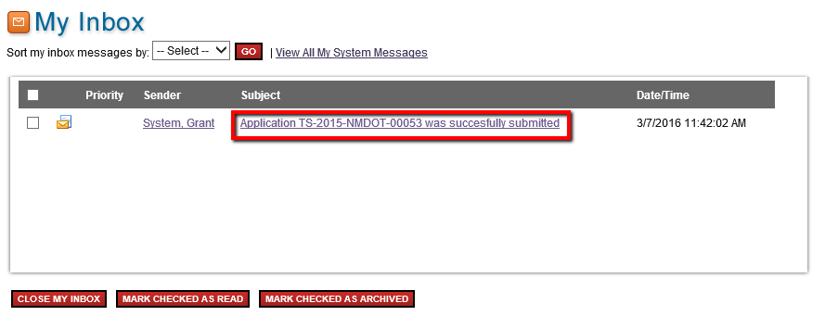
Figure 11: Displays the expanded My Inbox section of the My Home page.

My Tasks
The My Tasks section of the My Home page will display all documents that require your attention. Typically, unfinished applications or documents that require your attention for the next step in the process will display here. These documents will remain here until you have completed your task and changed the status of the document. For more information on changing the status of the document, visit the CHANGE THE STATUS section of this document.
To navigate to the Document menu of a task, click on the Name of the target task, as displayed in Figure 12.
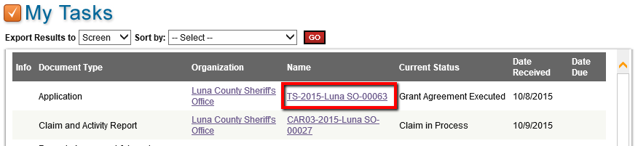
Figure 12: Displays the expanded My Tasks section of the My Home page.

My Applications / Executed Contracts & My Reporting Documents
You can easily search for any of your documents that are no longer available in the My Tasks section of the My Home page by utilizing the My Applications search page or the My Claim / Activity Reports search page. The My Applications search page will allow for you to search for any applications or executed contracts that you have in e-Grants. The My Claim / Activity Reports search page will allow for you to search for any Claim and Activity Reports that you have in e-Grants. To begin using a search page, click on the hyperlink located in the first navigation bar of the My Home page. From here, you are able to utilize the available fields as search criteria. Once you have entered your search criteria, click the SEARCH button. This will display a list of documents that match the given criteria. To navigate to the Document menu, click on the Name of the target document, as displayed in Figure 13.
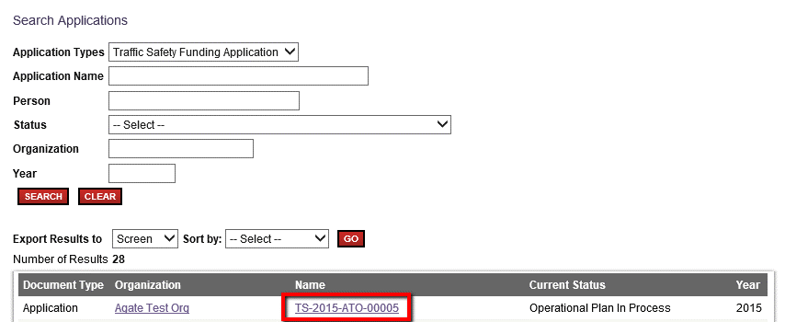
Figure 13: Displays the usage of the My Applications search page.

Document Menu
The Document Menu is the main menu for all documents with the system. From here, you are able to access all things associated with the document. Each document menu will have the name of the document, the name of the parent document if applicable. For example, a Claim and Activity Report will display the name of the Application that it applies to.
The Document Menu will also have an expandable Details section. By expanding this section, you will be able to view the type of the document, the organization it is for, your current document role, the current status of the document, the period date range and the due date if applicable, as displayed in Figure 14.
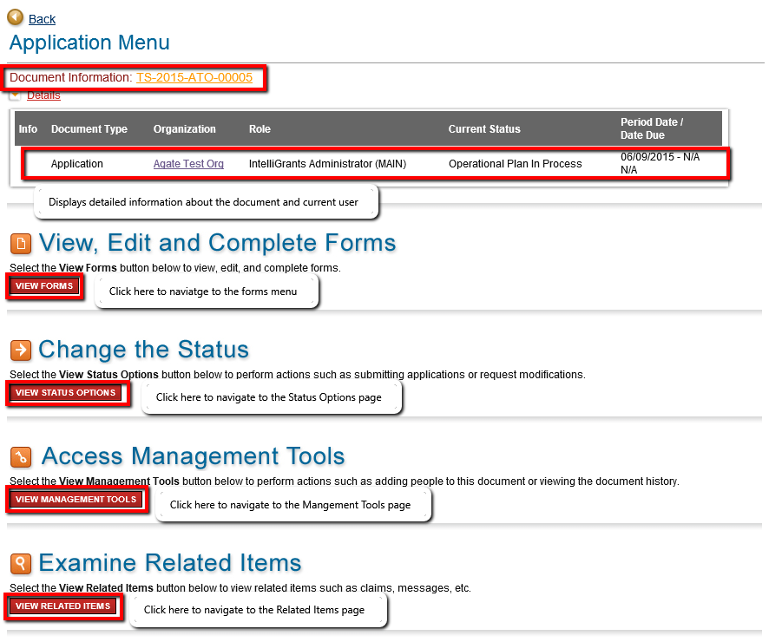
Figure 14: Displays the Document Menu page.

View, Edit, Complete Forms
The Forms menu will allow for you to view a list of navigational links that lead to PDF documents, and Forms that are within this application. It will also provide additional information, such as an icon that displays a visual representation of the forms status. PDF documents either display an Adobe Acrobat Reader symbol, or an Internet Explorer symbol. Hyperlinks to external locations will display an Internet Explorer symbol. The Forms menu will also display the name of the PDF / form, an icon if notes exists on the page, the name of the user whom created the page and when, and the name of the last user to modify the page and when.
To modify a form, click on the Page Name of the target form, as displayed in Figure 15.
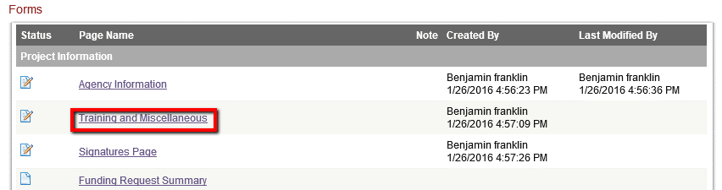
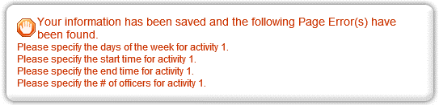
Figure 15: Displays the Forms menu, with an emphasis on a target form.
Once you are redirected to the form, complete all of the fields marked with a red asterisk and click the SAVE button.
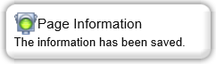
At times, you may encounter additional business rules based on the information that you have entered. If this is the case, you will notice the Page Errors section is displayed at the top of the form, which will include instruction on how to clear each error, as displayed in Figure 16. Once you have cleared all errors on the page, you will receive the following notification, displayed in Figure 17.
Figure 16: Displays the Page Errors section.
Figure 17: Displays after a successful page save.
To generate a PDF version of the current form, click the PRINT VERSION button. This will prompt you to either open or save the PDF version of this form.

Navigation Links
From the current form, you may also quickly navigate to other forms within the same sub-section. This is made possible by the Navigation Links section located at the bottom of the form. To navigate to the form, click on the Page Name of the target form, as displayed in Figure 18.
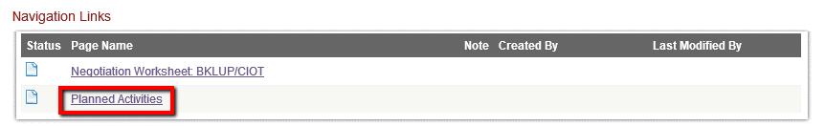
Figure 18: Displays the Navigation Links section located at the bottom of the form.

You Are Here
From the current form, you can also quickly navigate to other forms in another sub-section. This is made possible by the You Are Here section located at the top of the form. To navigate to the forms menu or Application Menu, click on the respective target link, as displayed in Figure 19.
Figure 19: Displays the Breadcrumbs section located at the top of the form.

Multi-Narrative Forms
In certain circumstances, forms will have the ability to be created more than once. We call this a Multi-Narrative Form. To create multiple versions of a form, first complete the form as you normally would, by entering information in the required fields. Once complete, if the form is multi-narrative, you will then have the option to click the ADD button, and by doing so it will redirect you to a new version of the form. Once again, you must first successfully complete this form. Once two or more forms are complete, you will have the ability to navigate between them using the drop down list that has appeared on the right hand side of the form, as displayed in Figure 20. This functionality can be utilized on pages such as ‘Planned Activities’ when there are more than 10 locations being targeted.
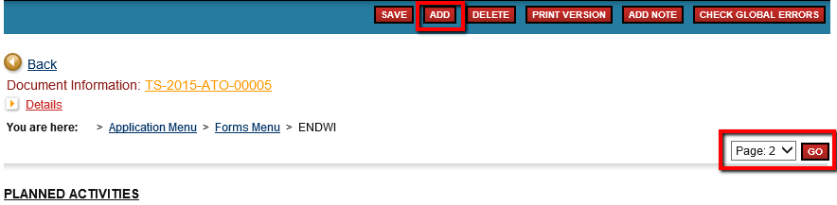
Figure 20: Displays a multi-narrative form’s navigational tools.

Repeatable Rows
In certain circumstances, forms will have fields that are repeatable for the opportunity to provide more information or data. This means that once you have filled in the field and clicked the SAVE button, another field for that information will appear underneath the first field. You may also see this functionality arise in a table, where entering information into a row of a table will then cause the table to display a new row after save.
To fully utilize a repeatable row, enter data into the fields available, then click the SAVE button. This will display a new field / row underneath the ones with entered data. This is displayed in Figure 21.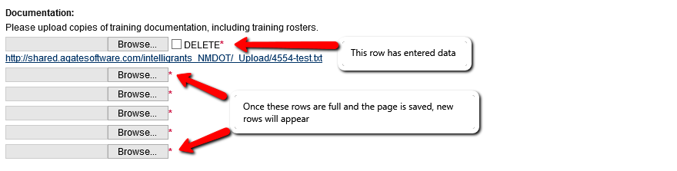
Figure 21: Displays the functionality of repeatable rows.

Change The Status
Once you have completed all of the forms available, you can submit and/or change the status of the document. By doing so, you will inform the next user in the process that you are complete with your task. From the Document menu, click on the VIEW STATUS OPTIONS button to navigate to the Status Options page.
It is important to note that once an application is submitted it will enter into a read-only status and cannot be changed!
From here, a list of possible statuses will appear. To change the status of the document, click on the APPLY STATUS button located directly beneath the desired status, as displayed in Figure 22.
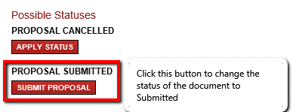
Figure 22: Displays the available statuses listed on the Status Options page.

Access Management Tools
The Management Tools page will list additional tools that are available to the user. These tools have different functions and are used to either view additional data specific to the document, or to complete additional tasks. To navigate to the Management Tools page, click the VIEW MANAGEMENT TOOLS button that is located on Document menu. This will redirect you to the Management Tools page, as displayed in Figure 23.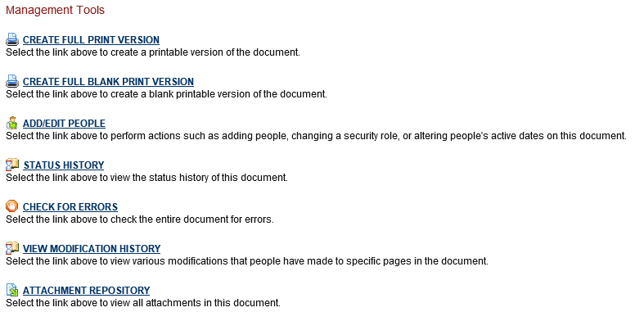
Figure 23: Displays a list of available management tools on the Management Tools page.

Add/Edit People
By default, user roles are automatically added to applications on initiation however, in the event that a new user is added to an organization after the application was initiated, the user will need to be added manually. This tool can also be used to discontinue access to the document past a set date and update a user’s role permissions for the document. This can all be done from the Add/Edit People management tool. From the Management Tools page click on ADD/EDIT PEOPLE to navigate to the current people assigned page.
To add an existing user to your organization, enter the user’s name in the search bar and click the SEARCH button. This will display a list of users that match the search criteria. Once you find your target user, place a check in the box to the left of their name, select their role and date at which they should gain access to the document, and then click the SAVE button. (As displayed in Figure 24)
It is ill advised to remove a member from the document since all historical data of the target member being associated with the document will be lost. Rather, you could inactive the user. This will instruct the system to discontinue access to the document past the set date. To inactivate a document member, enter in an inactive date and click the SAVE button.
To modify the document role of a member, select the desired role in the drop down list and click the SAVE button.
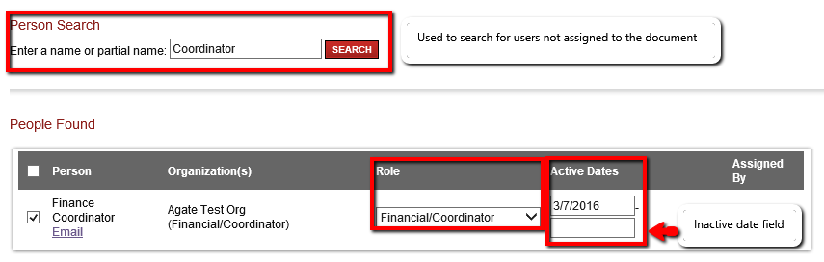
Figure 24: Displays the Current People Assigned page.

Examine Related Items
The Examine Related Items menu is of great importance. From an executed contract’s document menu, this is where you would go to initiate a supplemental Claim and Activity Report document, or from an in process claim, initiate an Inventory Record document. You would also come to this location to view any related system messages there were sent in association with this document.
From a Claim and Activity Report document, or Inventory Record document, you can utilize this menu to navigate back to the associated executed contract, or claim, as displayed in Figure 25.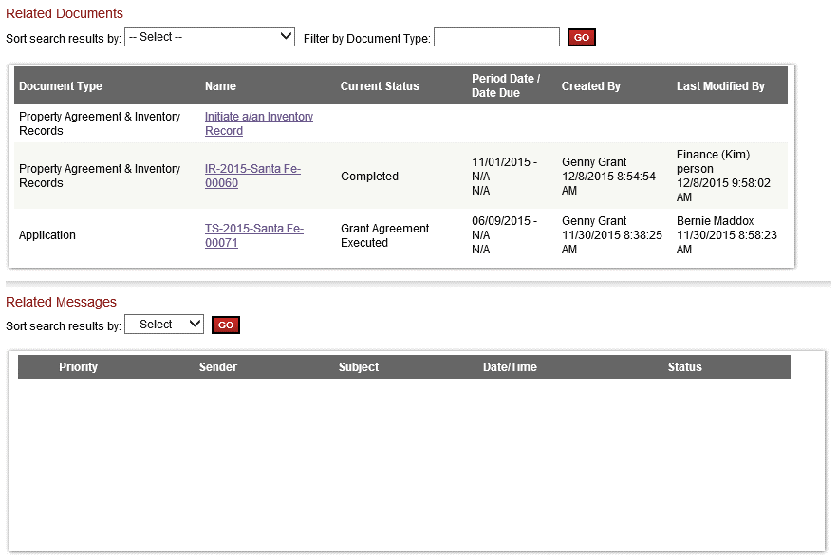
Figure 25: Displays the Related Items page.

My Reports
The My Reports menu is the main menu for the most common data export reports. From here, you are able to export structured data to PDF format. To navigate to the My Reports menu, click on the My Reports hyperlink located in the second navigation bar.
To navigate to a specific report, click on the name of the target report. This will redirect you to the Report page.
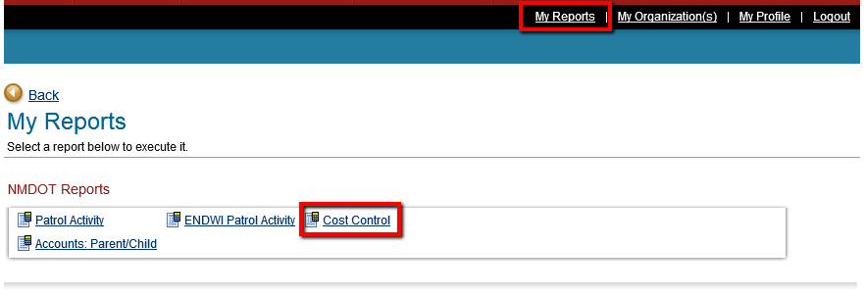
Figure 26: Displays the My Reports page.
On the report page, enter in the search criteria and click the EXECUTE button. This will generate a PDF report.
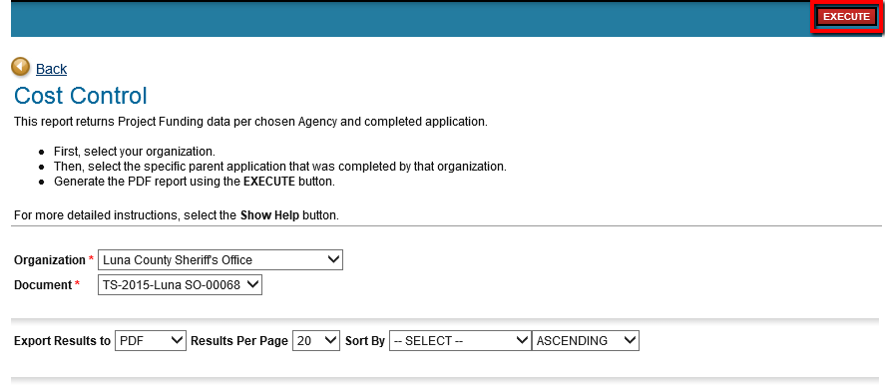
Figure 27: Displays the Cost Control Report page.

